https://event-driven.io/en/outbox_inbox_patterns_and_delivery_guarantees_explained/

In distributed environments, we have three main delivery guarantees.
At-most once : When we send a message and processing fails then the message will be lost and not handled.
At-least once : having this guarantee, we are sure that sent message will always be delivered. However, we are not sure how many times it will be handled. We can achieve that by re-publishing messages on the producer’s side (e.g. with an outbox pattern) or re-handling on the consumer side (e.g. with an inbox pattern). The disadvantage is that the message can be handled several times. We have to defend ourselves through correct idempotency handling.
Exactly-once - this semantic guarantee that sent a message will be handled exactly once. It is very difficult (sometimes even impossible) to achieve, as processing may fail on the multiple stages. If we want to have such guarantee then besides the retries we need to have correct idempotency support.
To properly handle at-least-once and exactly-once delivery, following patterns should be used:
- Outbox Pattern - it ensures that a message was sent (e.g. to a queue) successfully at least once. With this pattern, instead of directly publishing a message to the queue, we store it in temporary storage (e.g. database table). We’re wrapping the entity save and message storing with the Unit of Work (transaction). By that, we’re ensuring that the message won’t be lost if the application data is stored. It will be published later through a background process. This process will check if there are any unsent messages in the table. When the worker finds any, it tries to send them. After it gets confirmation of publishing (e.g. ACK from the queue), it marks the event as sent.
Why does it provide at-least-once and not exactly-once? Writing to the database may fail (e.g. it will not respond). When that happens, the process handling outbox pattern will try to resend the event after some time and try to do it until the message is correctly marked as sent in the database.
- Inbox Pattern - it is similar to Outbox Pattern. It’s used to handle incoming messages (e.g. from a queue). Accordingly, we have a table in which we’re storing incoming events. Contrary to outbox pattern, we first save the event in the database, then we’re returning ACK to queue. If save succeeded, but we didn’t return ACK to queue, then delivery will be retried. That’s why we have at-least-once delivery again. After that, an outbox-like process runs. It calls message handlers that perform business logic.
You can simplify the implementation by calling handlers immediately and sending ACK to the queue when they succeeded. The benefit of using additional table is ability to quickly accept events from the bus. Then they’re processed internally at a convenient pace minimising the impact of transient errors.
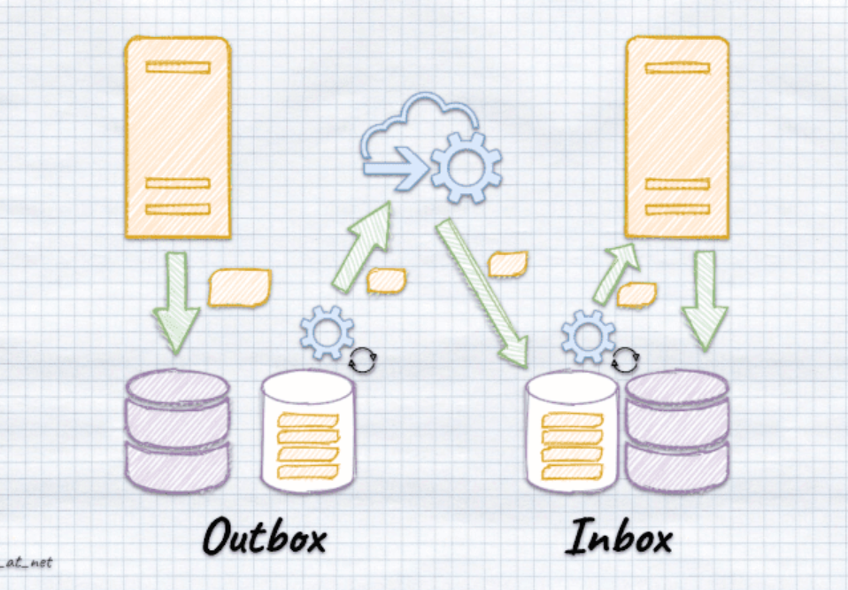
Transaction Outbox pattern
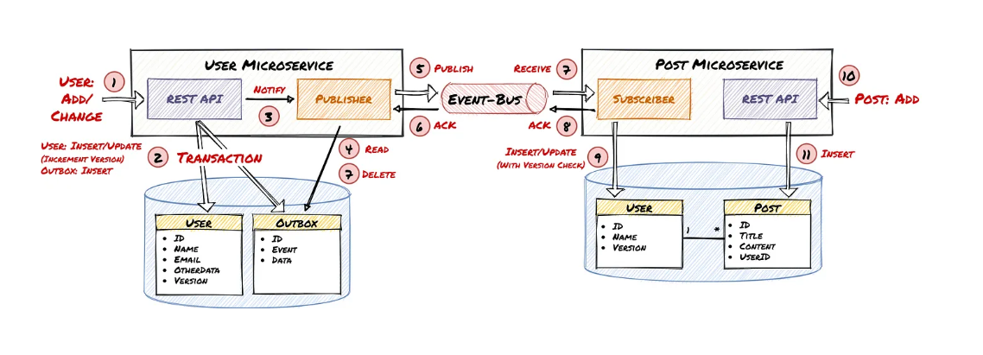
How to reliably/atomically update the database and send messages/events?
Solution
A service that uses a relational database inserts messages/events into an outbox table (e.g. MESSAGE) as part of the local transaction. An service that uses a NoSQL database appends the messages/events to attribute of the record (e.g. document or item) being updated. A separate Message Relay process publishes the events inserted into database to a message broker.
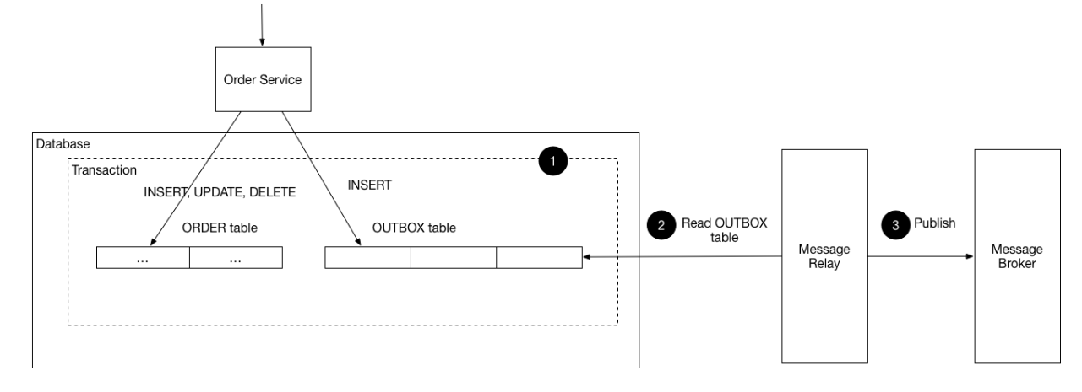
To sum up. Outbox and Inbox patterns are must-haves for getting at-least once or exactly-once delivery.

https://www.youtube.com/watch?v=u8fOnxAxKHk
We can use CAP library for outbox pattern
https://github.com/dotnetcore/CAP
https://www.youtube.com/watch?v=dnhPzILvgeo
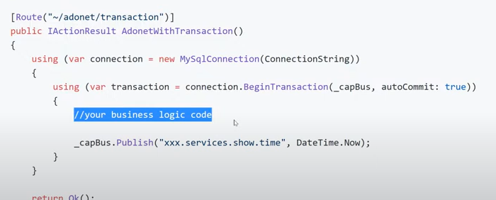
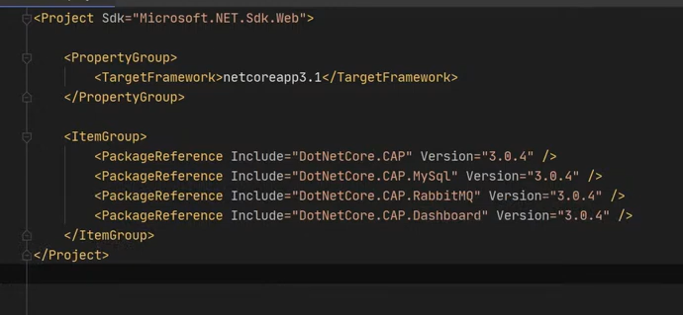

Outbox patterns using database interceptors & background job
https://www.youtube.com/watch?v=XALvnX7MPeo
Inbox and outbox pattern
https://www.youtube.com/watch?v=ebyR5RPKciw&t
https://github.com/devmentors/Pacco

Inbox Pattern
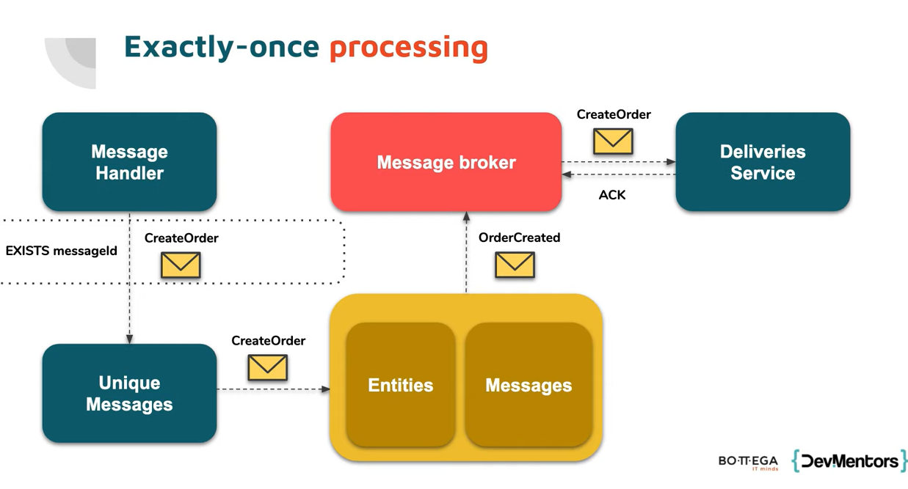
Outbox pattern
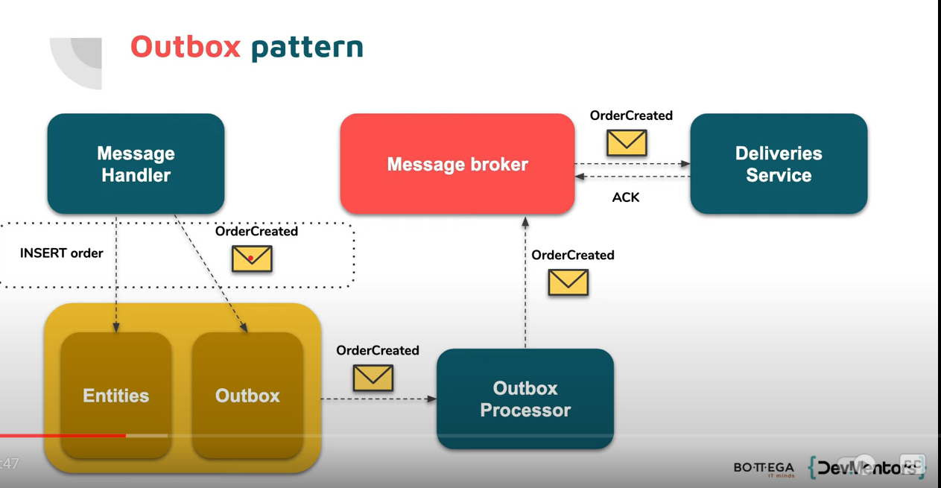

IHostedService – runs as a background job

Oubox pattern using simple transaction & background job
https://itnext.io/the-outbox-pattern-in-event-driven-asp-net-core-microservice-architectures-10b8d9923885
https://www.gokhan-gokalp.com/en/providing-atomicity-for-eventual-consistency-with-outbox-pattern-in-net-microservices/

